**Instructions for members on logging in to the De Partu website**  
The De Partu website uses a ‘plugin’ called Login Configurator. This has been set to take people back to the site home page once they have logged in. Unfortunately this is not happening, and even more unfortunately, this plugin is no longer being supported by the developer.   
  
If you click on Log In on the navigation bar of the site home page, you will see a screen that looks like this:  
  
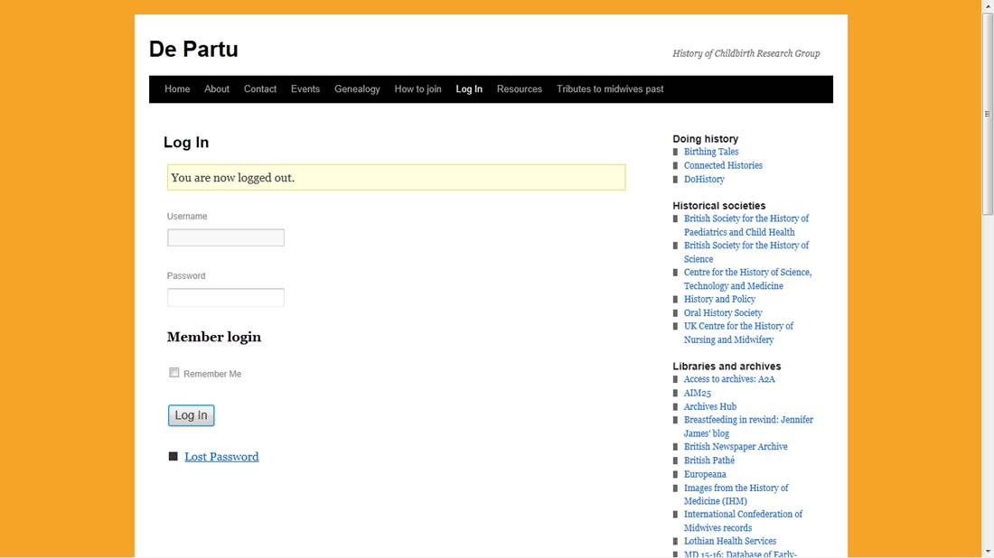

Once you have entered your username and password as provided to you, you will reach a page that looks like this:

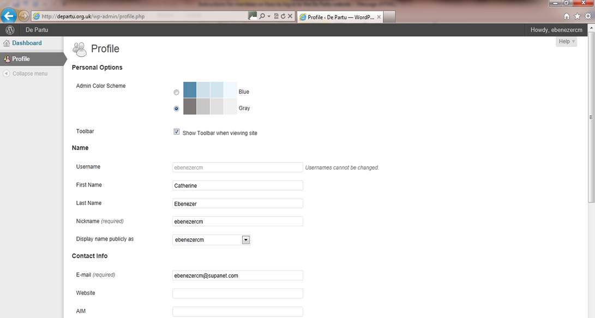

We recommend that you do not edit any of the settings here.   
  
To reach the main website, mouse over the white ‘De Partu’ link at the left hand end of the black bar at the top:

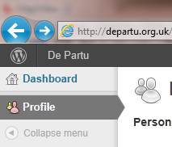

You will then see this:

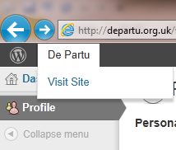  
  
When you click on the link ‘Visit Site’, you will be taken to the site home page again. You will see that the navigation bar now looks different: instead of Log In and How to Join, you will see Log Out and Members’ Area:

cid:image009.png@01CCDBA1.DFDD1F50

If you experience any difficulty with this process, please do not hesitate to contact me.  
  
Best wishes  
  
Catherine

Catherine Ebenezer

355 Crewe Road  
Wistaston  
Nantwich  
CW5 6NW  
  
01270 669589  
07876 494421

[webmaster@departu.org.uk](mailto:webmaster@departu.org.uk)